#DAST
DAST is security testing of a running application from the outside, without looking directly at its source code.

DAST using a Flipkart-like application
Imagine Flipkart has this flow:
Customer
↓
Flipkart Web / Mobile App
↓
API Gateway
↓
Product / Cart / Order / Payment APIs
↓
Backend Services
↓
Database
Suppose the development team has built the Product Search API:
GET /api/products?search=laptop
A normal customer sends:
GET /api/products?search=laptop
and gets:
{
"products": [
{
"name": "HP Laptop",
"price": 55000
},
{
"name": "Dell Laptop",
"price": 62000
}
]
}
Everything looks fine.

Now comes DAST
Before releasing this version to customers, Flipkart deploys it to a staging environment.
Developer
↓
Code
↓
Build
↓
Deploy
↓
STAGING ENVIRONMENT
↓
DAST
↓
Security Testing
↓
Production
A DAST tool such as OWASP ZAP behaves somewhat like an automated security tester.
It doesn't need to read the Python/Java source code.
Instead, it sees:
https://staging.example/api/products
and interacts with the application through HTTP.

Example 1 — SQL Injection
Suppose developers accidentally implemented:
GET /api/products?search=<user input>
in an unsafe way.
A DAST scanner might send unusual input designed to test whether the search parameter is being interpreted as SQL rather than treated purely as data.
Conceptually:
Normal:

search=laptop
↓
Application
↓
Normal response

DAST:

search=<malicious test input>
↓
Application
↓
Unexpected database behavior
↓
🚨 Possible SQL Injection
The important thing is that DAST discovered the issue by interacting with the running application.
It didn't need to know that the backend was written in Java, Python, Node.js, etc.
###

SAST VS DAST
SAST checks the code. DAST checks the running application.

####
LAB:
Step 1 — Clone your GitHub project
On your Windows machine:
git clone https://github.com/letslearn207/python-app-sast-demo.git
Then:
cd python-app-sast-demo
Check:
dir
You should see:
app.py
Jenkinsfile
.github
Step 2 — Check what's inside app.py
Run:
notepad app.py
or open it in VS Code.
This is important because this is the exact application that CodeQL is already scanning.
Step 3 — Run THIS app locally
First check Python:
python --version
Then install Flask if required:
pip install flask
Now:
python app.py
If the application starts successfully, you'll get something like:
Running on http://127.0.0.1:5000
Then open:
http://127.0.0.1:5000/ping?cmd=hostname
http://127.0.0.1:5000/ping?cmd=whoami
###
Download https://www.zaproxy.org/download/
OWASP ZAP

Open ZAP
After installation:
Windows Start → search ZAP → open Zed Attack Proxy
The first time it opens, you may see:
Persist ZAP Session?
For this simple demo, you can choose:
No / Don't persist
Then you'll reach the ZAP main screen.
Keep your Flask application running
You already did this successfully.
Your first terminal should still show:
* Running on http://127.0.0.1:5000
And this URL works:
http://127.0.0.1:5000/ping?cmd=whoami
Do not close that terminal.
###
First let ZAP see your application
Once ZAP is open, look for Quick Start.
Choose:
Automated Scan
You'll get a field:
URL to attack:
Enter:
http://127.0.0.1:5000/ping?cmd=whoami
For your particular application, I'm recommending this URL instead of just /, because your Flask app has no / endpoint.
Then click:
Attack
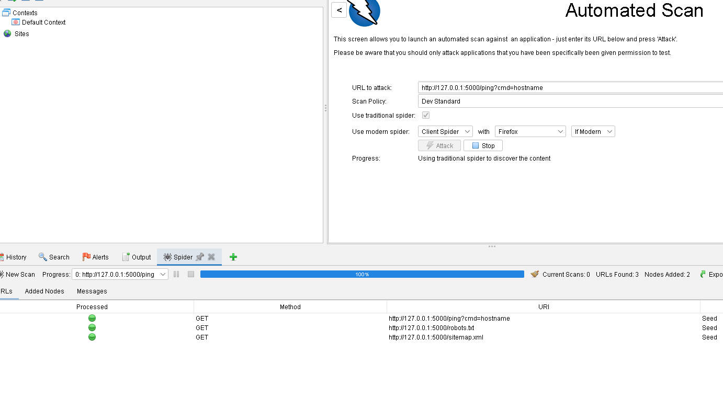

##

Lets perform via github actions
Create a new GitHub Actions workflow
In your repository create:
.github/workflows/dast.yml

name: DAST - OWASP ZAP
on:
push:
branches:
- main
workflow_dispatch:
jobs:
dast:
name: OWASP ZAP DAST Scan
runs-on: ubuntu-latest
steps:
# 1. Get application source code
- name: Checkout repository
uses: actions/checkout@v4
# 2. Install Python
- name: Setup Python
uses: actions/setup-python@v5
with:
python-version: "3.12"
# 3. Install Flask
- name: Install dependencies
run: |
python -m pip install --upgrade pip
pip install flask
# 4. Start Flask application
- name: Start Flask application
run: |
python app.py > flask.log 2>&1 &
# 5. Wait until Flask is ready
- name: Wait for application
run: |
for i in {1..30}; do
if curl -s "http://127.0.0.1:5000/ping?cmd=whoami" > /dev/null; then
echo "Application is running"
exit 0
fi
echo "Waiting for application..."
sleep 2
done
echo "Application failed to start"
cat flask.log
exit 1
# 6. Run OWASP ZAP
- name: OWASP ZAP Full Scan
uses: zaproxy/action-full-scan@v0.13.0
with:
target: "http://127.0.0.1:5000/ping?cmd=whoami"
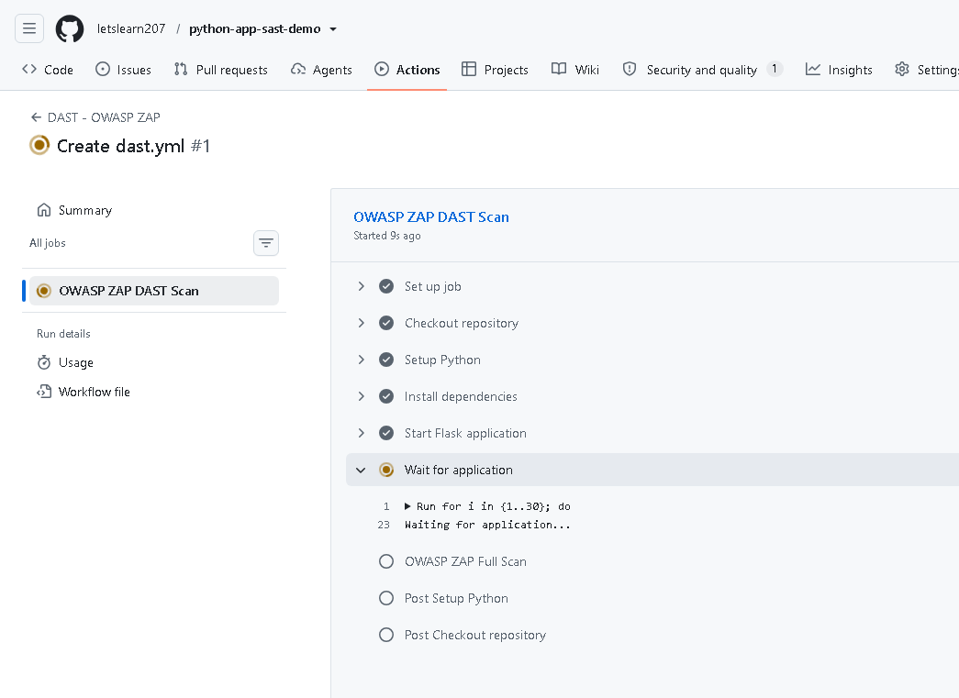
Watch the workflow
You'll see:
Checkout repository ✅
Setup Python ✅
Install dependencies ✅
Start Flask application ✅
Wait for application ✅
OWASP ZAP Full Scan 🔄
The interesting step is:
OWASP ZAP Full Scan

Where is the DAST report?
This is important.
The ZAP GitHub Action can maintain findings as a GitHub issue and attach scan reports to the workflow run. The ZAP documentation describes HTML/Markdown reports being attached to the workflow run.
After the workflow:
Go to
Actions → DAST - OWASP ZAP → your workflow run
Then look near the bottom for:
Artifacts
You should see something like:
zap_scan
Download it.
You'll get the ZAP report.

